**Lab 3: Monitoring the Future Study**

**Part I: Preparing the Data**

For this lab, you will begin working with the Monitoring the Future data for 2016, the most current year for which data are available. The 2017 will not be available until October.

1. a. In your Data folder, create a new folder named Lab 3. Go to Blackboard. In Data>MTF you will find two files: MTFData_2016.csv and MTFCodebook_2016. Save them into your Lab 3 folder.

b. Open the Codebook. Click Frequencies and scroll down until you find a list of questions and frequency tables.

2. Find the code V# corresponding to the variables in the bulleted list below. Copy the column into a new Excel.csv file named Lab3. Replace the corresponding V# with a variable name. Choose a name **without any spaces** (you can use underscores for spaces). Keep the variable names short but informative. When this is completed, save the csv file. **Make sure you save as a .csv file** and not as an Excel worksheet!

* Sex
* Race
* Mother Ed Level
* Mother Paid Job
* Ticket (moving violation)
* Drive (how far)

3. a. Open RStudio. (Save any old work that you want to return to later.)

* Click New Project
* Existing Directory – browse to find your Lab 3 folder.
* Create project called Lab 3
* Open a new script. Click the +, select R Script. 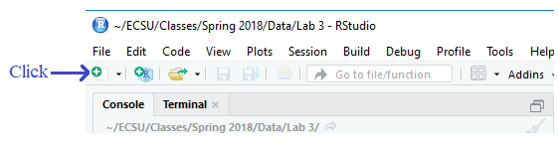
* Save the script: File>Save as. Your screen should be similar to the one below. Give the script a name: Lab 3S. Then click Save.

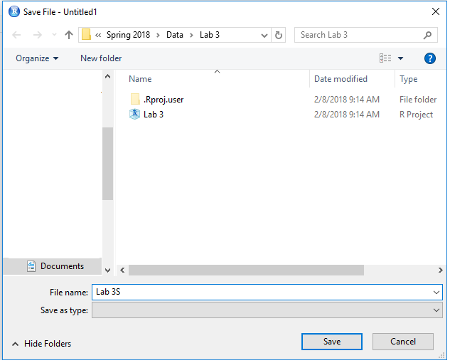

After Clicking Save, check out your Files tab:

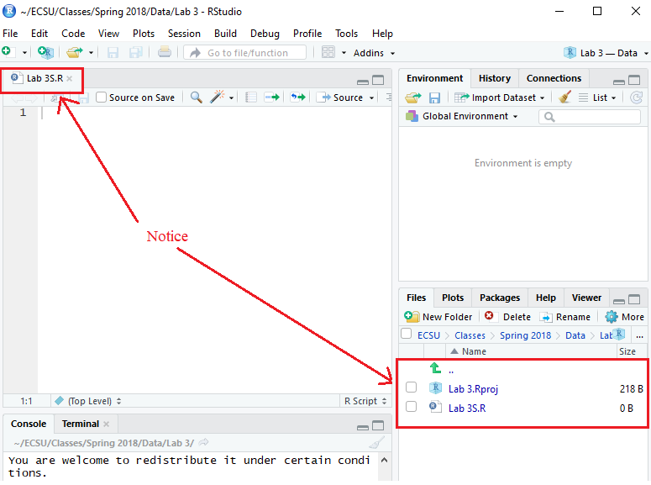

4. I did not create the .csv file with the data when I created this lab description. Where did that file appear? Do you see it in your file folder?

If you look in the folder, you should see something like what is shown below: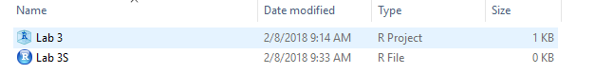

b. Read your newly created csv file into RStudio and name it DataLab3. Check that you have done this correctly with head(DataLab3).

c. For now, the variable values are all numeric. Next time you will use the Codebook and give the numeric values labels. (How did you handle the missing values?)